***Christmas pattern scarf***

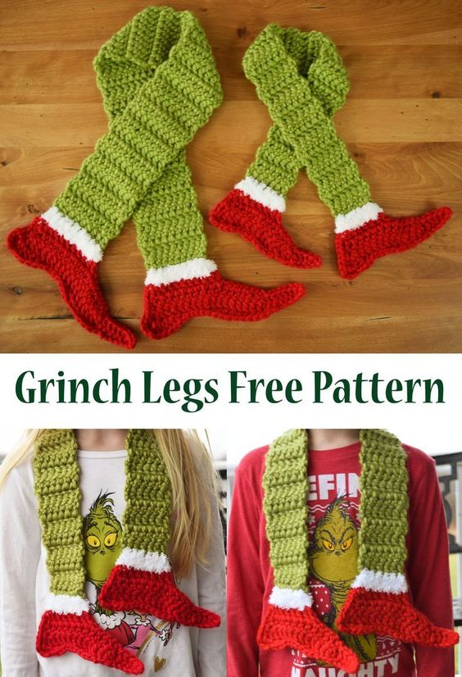

*Product : Lovely Christmas shawl - Color: Green - Red. - Material: Cotton.Product Advantages: ⁃ Design beautiful products and eye-catching Christmas motifs to beautify the Christmas season. ⁃ Breathable cotton material - safe.*